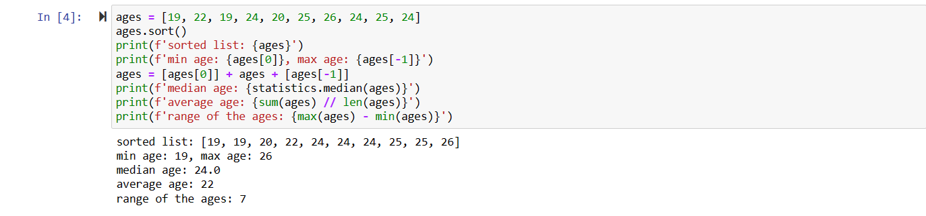

Initially we sort the given array using the sort method

Then we find the minimum age in the given array using them "min" method for arrays

Similarly, we find the maximum age using "max" method for arrays

Now we add the minimum and maximum ages to the initially array

We sort the array again using sort method

Then to find the length of the array we used the "len"

Using the length, we apply the median formula and find the median of the ages

To find the average of ages we need to find the sum first so

Using the "sum" method we find the total sum of the ages in the given array

To find the range of ages we just subtract the minimum age and maximum age

Then finally print all the values using "print"

Question 2:

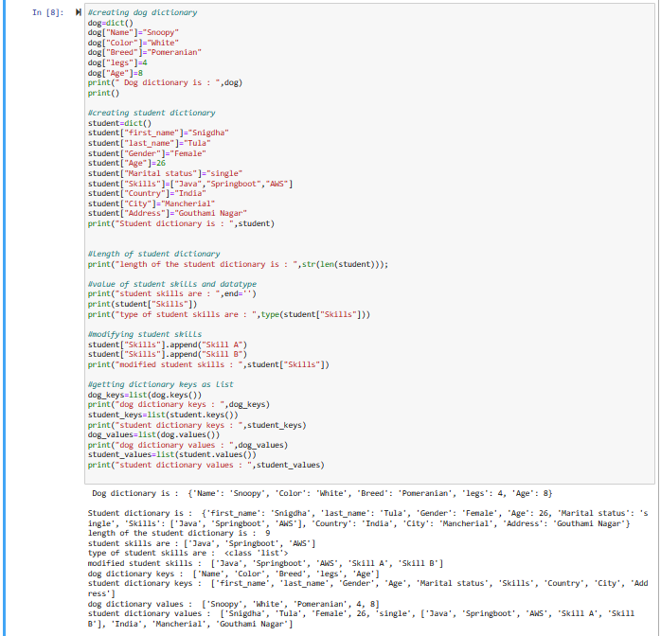

Initially we create a dictionary named as dog using the "dict()" function

Then we add various attributes and their values into the dictionary

then we print the whole dog dictionary

Similarly we create student dictionary using the "dict()" function

Then we add various attributes like first_name, gender, skills, Country etc.. as mentioned in the question

Then we print the whole student dictionary

To find the length of the student dictionary we use the "len" method

To print only skills from the student dictionary we mention it as "student["Skills"]"

Then to print the type of the skills attribute we use "type" method

Now to add some skills into the existing dictionary we use "append" method

to get dictionary keys as a list we use list method and keys method

similarly to get values as list we use list and values method

Question 3:

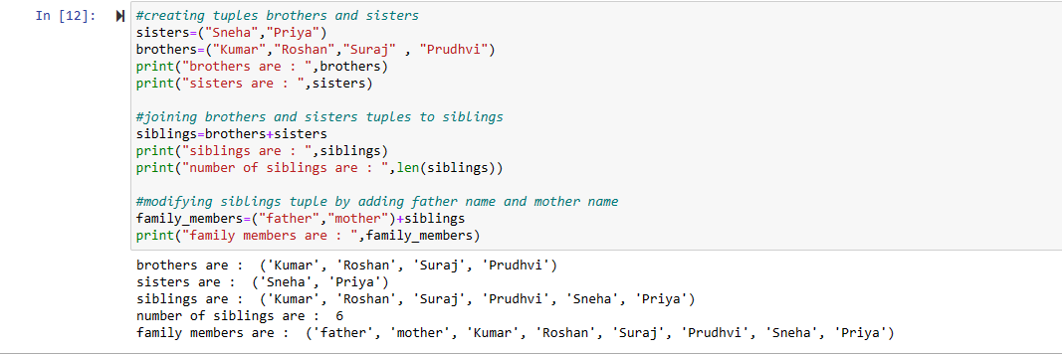

Initially we create two tuples name sisters and brothers and add some data into it

The we join the 2 tuples using the "+" symbol and name it as siblings

Then find the length of sibling’s tuple we use the "len" method

to the sibling’s tuple we add father and mother names and name the new tuple as family members

Question 4:

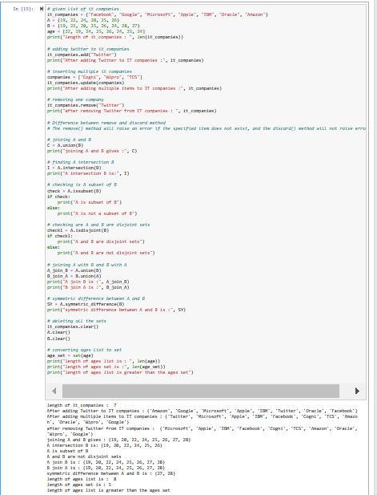

By using length function we calculated length, by using add function we added “twitter” to existing IT companies list, to add multiple IT companies we use update, By remove function we can remove specific list in array, Discard function is used for remove element though it is not in list and will not rise error,

The union() method returns a set that contain all items from the original set,and all items from the specified set(s)

Intersection returned set contains only items that exist in both sets, or in all sets if the comparison is done with more than two sets

Symmetric method returns a set that contains all items from both set, but not the items that are present in both sets.

The isdisjoint() method returns True if none of the items are present in both sets, otherwise it returns False.

Question 5:

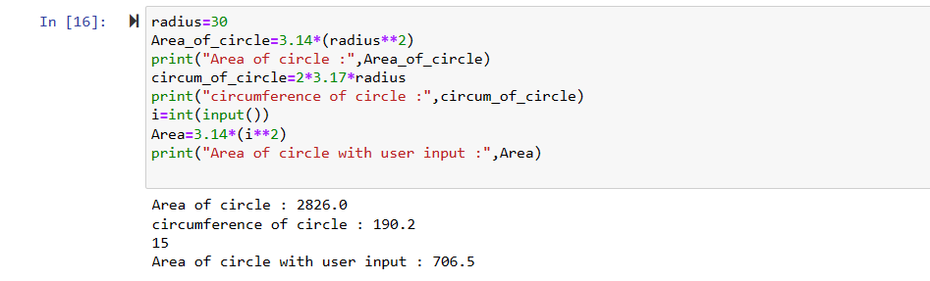

Initially we are assigning the given radius to a variable named "radius"

Then area of circle is 3.14xr^2

and we print the area

Similarly the circumference of the circle is 2x3.14xr

and we print it

to take the user input we use the input() function

and calculate the area using the above formula

Question 6:

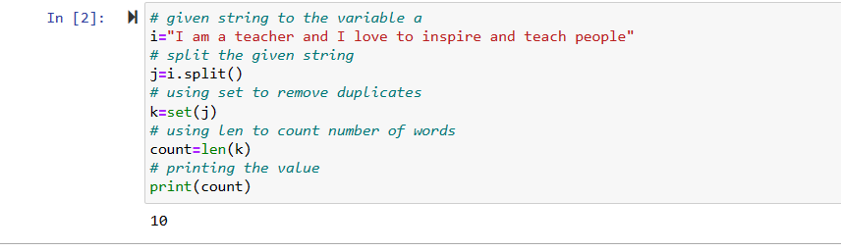

we assign the given string to a variable

then with split() function we split the sentence into words

to remove the repeated words we convert the string into a set

then to count the no of words we use the "len" method

Question 7:

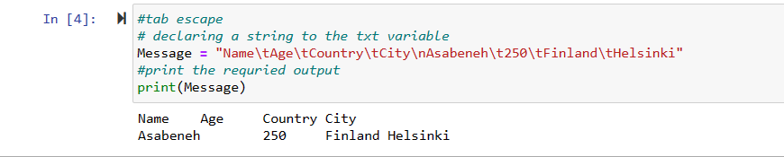

To create the space between the words as shown int the question we use"\t" known as tabspace

And to move to a new line we use"\n"

Question 8:

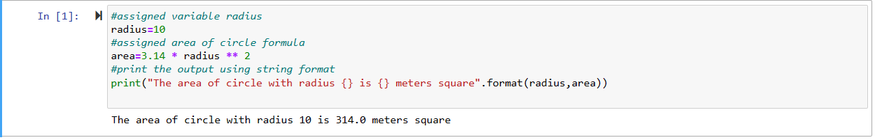

we assign the radius=10 and calculate the area using the given formula

To print the output we using string formatting

we use flower braces and format() function to display the output

Question 9:

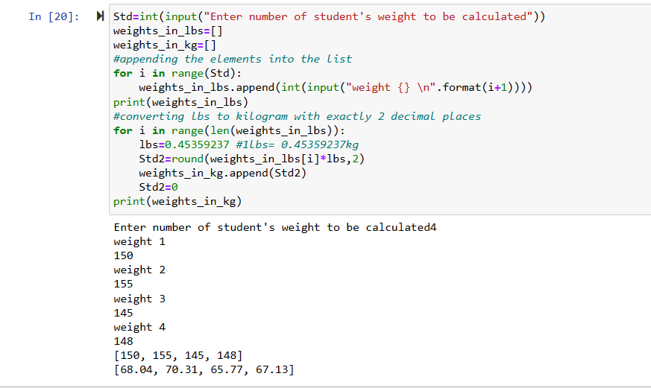

initially we take the input form the user for no of students weights need to be converted

then we take the weights of the students using a for loop and we add it to the weightinlbs array using the append method

now to convert lbs into kgs with exactly 2 decimal point

we use a for loop with range as length of weightinlbs array

then we create a variable as temp and we multiply the values in weightinlbs array with 0.45 and with the help of round function we round it to exactly 2 decimal points

and append the temp variable values into weightinkgs array

Question 10:

